Resume Builder

Display

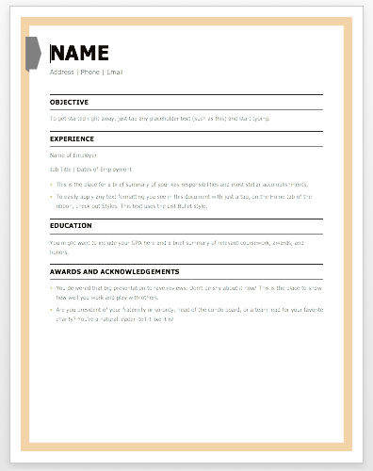

Print Page

Try the Other